Open Call for Collaborative Art Projects
APPLICATION FORM

1) Activity Title and Artistic Discipline(s)
Please provide your activity title and list which artistic discipline(s) this activity will utilise.

2) General information of Lead Applicant
  - Full Name:
  - Email:
  - Telephone:
  - Name of Registered Entity:
  - Address:

3) Detailed description of the Project and Work Plan (max. 750 words)
Provide a clear and detailed description of the proposed project, including concept, methodology, artistic approach and expected outputs.

4) Gender Responsiveness and Disability Inclusion (max. 500 words)
Explain how your project applies a gender responsive approach, including how it identifies and addresses gender-related needs, gaps, or barriers. If your project involves people with disabilities, describe the activities, considerations and/or partners that will support their full and accessible participation.

5) Location, Timeline, and Duration of Project
Specify the location(s) of the project, the start and end dates, and the overall project timeline. Please provide a detailed monthly-by-month description of the activities planned using the template below.
 | Timeline
Activities | July | August | Sept | October | November

Note: All activities must be completed by November 2026.
Example:
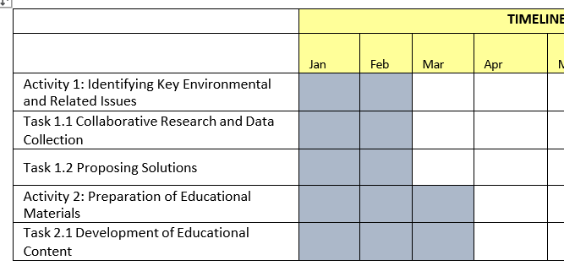

6) Roles of the Team Members and Project Management (max. 500 words)
Provide a list of all team members and explain how their role(s) will support the project. Describe the project’s management structure and how each role will support this. Please attach the CVs and/or short biographies of all team members, highlighting their relevant experience.

7) Target Audience and Outreach Strategy (max. 300 words)
Describe the intended audience(s) and how you plan to reach and engage them.

8) Objectives and Relevance to the Technical Committee on Culture (max. 500 words)
Describe the objectives of the project and explain how they align with the goals of the Technical Committee on Culture, particularly in fostering collaboration between Greek Cypriot and Turkish Cypriot communities.

9) Budget Breakdown
Provide a detailed breakdown of all project costs using the table below. For each budget category, list the number of units or persons, the unit cost and the total amount. Include short justifications within the “Description/ Examples” column to explain why each cost is necessary/ which part of the project it corresponds to.
Budget Category | Description / Examples | No. of Units / Persons | Unit Cost (€) | Total (€)
Creative Contributors | Project coordinators, artists, curators, facilitators, writers
Travel & Transport | Airfare, train/bus tickets, taxi, local transport for participants and staff
Venue & Facilities | Rental of community centers, galleries, auditoriums, or partner spaces
Technical Equipment | Audio-visual equipment, projectors, lighting, sound systems, computers, recording devices
Project Materials & Supplies | Art materials, stationery, exhibition panels, signage, printing of promotional materials
Activity Implementation Services | External services required for project delivery, including:
Installation & De- installation | Exhibition setup, stage assembly, venue preparation
Logistics & Transport | Shipping artworks, instruments, equipment, or publications
Technical Support | Sound engineering, lighting, film projection, subtitling
Documentation | Photography, video recording, audio documentation for reporting and visibility
Interpretation / Translation | Translation of printed or digital materials and live interpretation
Community Engagement & Outreach | Workshops, focus groups, panel discussions, interactive sessions
Promotion & Communication | Programme brochures, posters, social media campaigns, press releases, website updates
Publications & Knowledge Products | Reports, catalogues, guides, design and printing, translation, editing
Contingency | Optional allocation for unforeseen expenses (typically 5–10% of total budget)
TOTAL EXPENSES | Total expenses for the project

10) Registered Entity
As Lead Applicant, I hereby confirm that this submission is under a registered entity.
Name:
Signature:
*Make sure to upload proof of the registered entity and proof of collaboration with a registered entity (if applicable).
Submission Check List
☐ Upload completed application form
☐ CVs and/or short biographies of all team members attached
☐ All team members registered on the TCC Networking Platform
☐ Upload proof of registered entity

☐ Upload proof of collaboration with a registered entity (if applicable)

